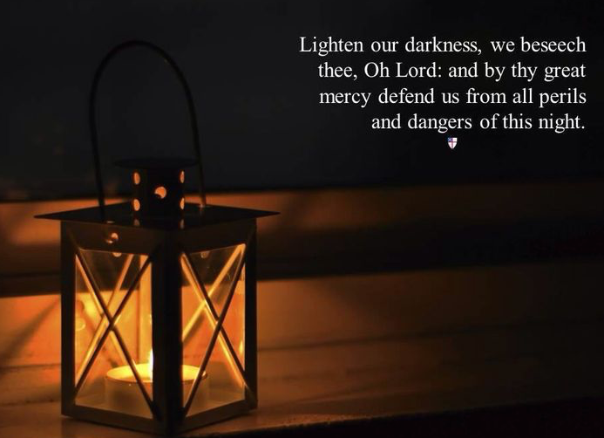
“THE LORD ALMIGHTY GRANT US
A PEACEFUL NIGHT AND A PERFECT END.
AMEN.”
Spiritual but not religious?
Seeking a mystical experience?
Looking for a way to bring a perfect Saturday on the North Fork to a perfect end?
Join us at Holy Trinity Episcopal Church
768 Main Street, Greenport
at 8:00 pm
Saturday, August 5th

Compline is the last of the daily offices traditional chanted by monks before retiring for the evening. Expect to be transported to another time and place when the choir, composed of about a dozen trained voices, will process into the church gather around the altar and chant ancient melodies as well as contemporary hymns. The congregation sits quietly in the candlelit and incensed space participating through silent prayer and mediation.

This service lasts approximately a half hour to forty-five minutes. All are welcome regardless of your religious affiliation.
Dress is “come as you are casual.”

